SUMMARY SHEET

EXPERIMENT 1

1. FOR WATER AND RED LIGHT AT EXTREME END OF SPECTRUM

k | = | 1 | First Order Rainbow | θ₁ =129.0°  137.0° | ₁ | = 137.0 | ±5.0°
k | = | 2 | Second Order Rainbow | θ₂= 129.0° | ₂ | = 231.0 | ±3.0°
k | = | 5 | Fifth Order Rainbow | θ₅= 126.0° | ₅ | = 486.0 | ±4.0°

2. LIQUIDS A AND B USING SECOND ORDER RAINBOWS
For Liquid A | θ₂ = 105.0° | ₂= 255.0 ±3.0°
For Liquid B | θ₂ = 89.5° | ₂= 270.5 ±3.0°
For n = 1 | θ₂ = 0.0..º | ₂= 0.0..º
Gradient of graph |  | = 0.84 ±0.07
Extrapolated, n =2, | θ₂, value of | = 304 ±25º

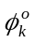

500

400

300

200

100
k
0 1 2 3 4 5

Figure E 1.1.

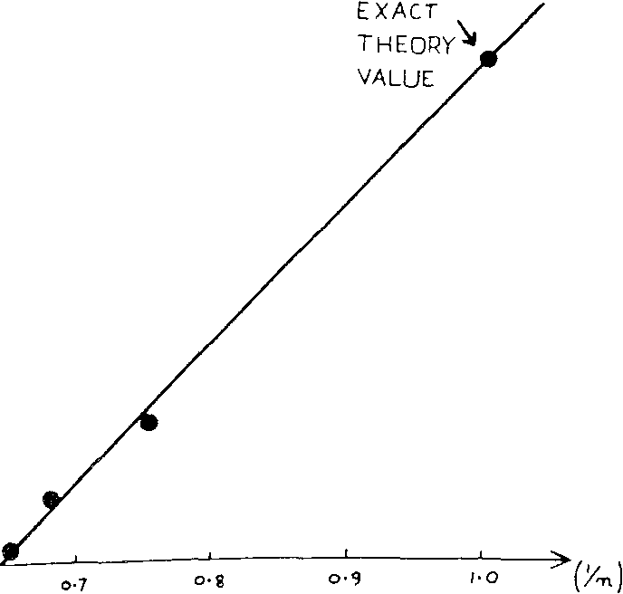
0.6 0.7 0.8 0.9 1.0
Exact theory value
1.0

0.9

0.8

0.7

1/n

Figure E 1.2

SUMMARY SHEET
EXPERIMENT 2
Is the total momentum conserved? YES /NO
Accuracy of computer calculation 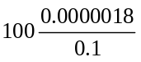0.002% 0:1
(RMS velocity = 0.1)

Time | Total Energy
0 | -1.61499
2 | -1.62886
4 | -1.62878
6 | -1.62301
12 | -1.62882
18 | -1.62599
24 | -1.62796
30 | -1.62703
50 | -1.62753
70 | -1.62676
90 | -1.62580
130 | -1.62713
180 | -1.62409

Does the system conserve energy? YES/NO (~ ±1%)

Equilibrium value of E_{k}*  Equilibrium time SD | (Average 24 to 180)  (see Fig. E 2.1 ) | = 0.534 ±0.05  (10 to 20 )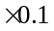
Value of S recorded |  | > 20, e.g. 60
Value of  (for SD=60) | (see Fig. E2.2 ) | = 0.503
Accuracy of |  | = ±0.02

For what time number range is graph, obtained using first value of SR, linear? SZ = 18 to 24

Gradient of this graph in linear region 0.027 to 0.47
Accuracy of gradient = 0.002

Gradient of AVERAGE <R²> in linear region = 0.035

Accuracy of this gradient = ± 0.01
* delete as appropriate

Is the system a liquid/solid? Liquid/Solid*

Mean Momentum of the system at requested steps (S)
S | <VX,1> | <VY,1> | <PX> | <PY>
0 | 0.0000000 | 0.0000000 | 0.000000 | 0.000000
40 | 0.0000010 | 0.0000016 | 0.000048 | 0.000077 |  |  | . p.E.
80 | 0.0000018 | 0.0000001 | 0.000086 | 0.000005
120 | 0.0000014 | 0.0000007 | 0.000067 | 0.000034
160 | 0.0000016 | 0.0000010 | 0.000077 | 0.000048
 |  |  |  |  |  |  |  | -2-3
 |  |  |  |  |  |  | K.E.

Energy of the system at requested steps (S)

S | <VX,2> | <VY,2> | <KE> = T* | <U> | <E>= Total Energy
0 | 0.0173874 | 0.0142851 | 0.760140 | -4.7502660 | -1.61499
2 | 0.0162506 | 0.0131025 | 0.704474 | -4.6666675 | -1.62886
4 | 0.0124966 | 0.0089562 | 0.514867 | -4.2873015 | -1.62878 |  | ¢0 80 120
 |  |  |  |  |  |  | time $
6 | 0.0077405 | 0.0039113 | 0.279643 | -3.8053113 | -1.62301
12 | 0.0118740 | 0.0120959 | 0.575278 | -4.4081878 | -1.62882
 |  |  |  |  |  |  | Figure E2.1
18 | 0.0099579 | 0.0075854 | 0.421039 | -4.0940627 | -1.62599
24 | 0.0108577 | 0.0116978 | 0.541332 | -4.3385782 | -1.62796 |  | Variation of K.E and P.E
30 | 0.0126065 | 01000340 | 0.543372 | -4.3407997 | -1.62703
50 | 0.0127138 | 0.0103334 | 0.553133 | -4.3613165 | -1.62753
70 | 0.0088657 | 0.0158292 | 0.592678 | -4.4388669 | -1.62676
90 | 0.0107740 | 0.0076446 | 0.442087 | -4.1357699 | -1.62580
130 | 0.0073008 | 0.0177446 | 0.601090 | -4.4564333 | -1.62713
180 | 0.0097161 | 0.0096426 | 0.464609 | -4.1773882 | -1.62409

All values are in reduced units. <KE> is the mean kinetic energy per atom. <U*> is twice the potential energy. <VX,2> and <VY,2> are the mean values of the squares of the X and Y velocity components, as described in the question. Similarly <VX,1> and <VY,1> are the mean values of the velocity components. <PX> and <PY> are the mean momentum per particle.

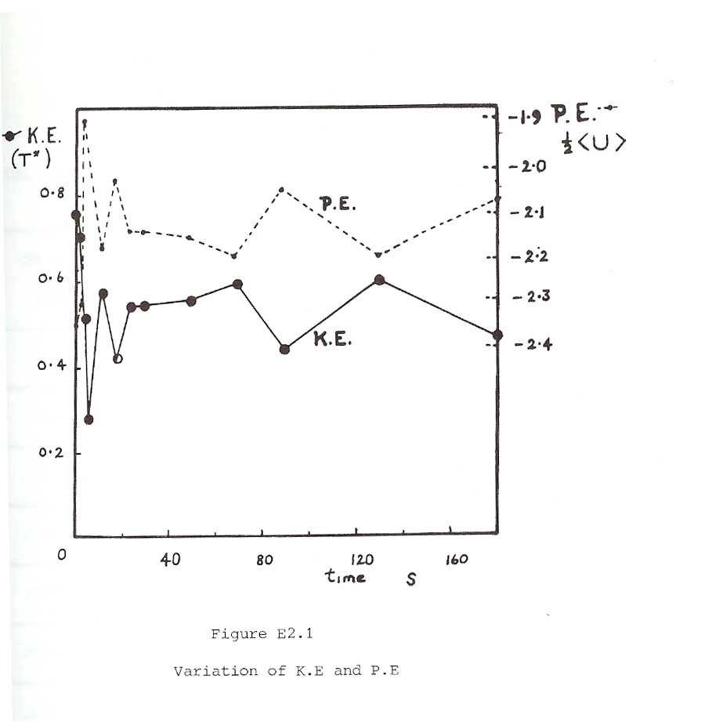
Figure E 2.1

Variation of K.E and P.E.
0 40 80 120 160
KE (T*)
0.8

0.6

0.4

0.2

0
-1.9 PE
½<U>
-2.0

-2.1

-2.2

-2.3

-2.4
P.E.
K.E.

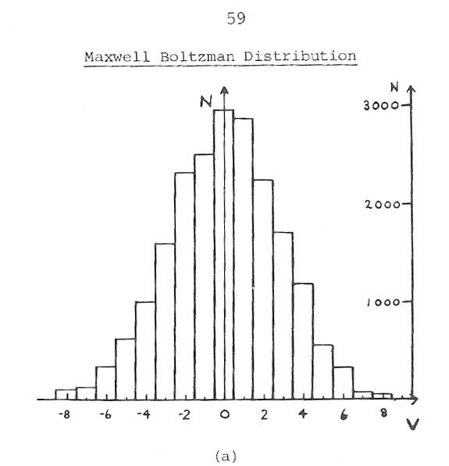
V
Maxwell Boltzmann Distribution
-8 -6 -4 -2 0 2 4 6 8
(a)
N
N
3000

2000

1000

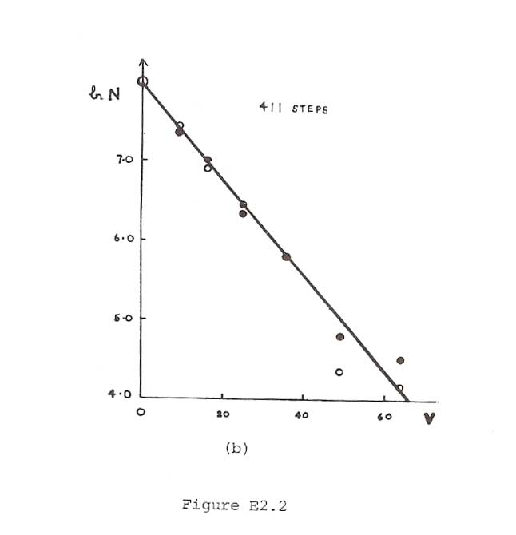
LnN

7.0

6.0

5.0

4.0
411 Steps
0 20 40 60
V
Figure E2.2
(b)

10⁻²<R²>

8

6

4

2
0 6 12 18 24
Time step s

Figure E2,3

<R^{z}> curves as a function of time

TYPICAL RESULTS : NOTE THE LARGE VARIATIONS IN THE VALUES OF <R²>

Time Number  SZ - S-SR | SR = 261  <R²> | SR = 301  <R²> | SR = 334  <R²> | SR = 370  <R²> | AVERAGE  <R²>
0 | 0 | 0 | 0 | 0 | 0
2 | 0.00088 | 0.00067 | 0.00091 | 0.00079 | 0.00081
4 | 0.00287 | 0.00276 | 0.00382 | 0.00298 | 0.00311
6 | 0.00523 | 0.00628 | 0.00858  .  I | 0.00623 | 0.00658
8 | 0.00797 | 0.01101 | 0.01449 | 0.01039 | 0.01097
10 | 0.01143 | 0.01656 | 0.02095 | 0.01523 | 0.01604
12 | 0.01528 | 0.02235 | 0.02768 | 0.02022 | 0.02138
14 | 0.01874 | 0.02845 | 0.03453 | 0.02564 | 0.02684
16 | 0.02184 | 0.03539 | 0.04157 | 0.03160 | 0.03260
18 | 0.02526 | 0.04293 | 0.04902 | 0.03833 | 0.03889
20 | 0.02979 | 0.05080 | 0.05718 | 0.04532 | 0.04577
22 | 0.03538 | 0.05918 | 0.06605 | 0.0510 | 0.05303
24 | 0.04063 | 0.06784 | 0.07533 | 0.05569 | 0.05987

